

HOW TO – Windows Child Configuration
(For Windows Child V3.0)

Dec 12, 2009
Version 1.0

Table of Contents
Summary 3
Prerequisites 3
GroundWork Monitor Setup 3
NSCA Communication Setup 3
Create Windows Child Build Directory 4
Enable Monarch Externals 4
Configure Monarch Group for Windows Child targets 5
Upload and Import Windows Child Profiles 6
Create Windows Child Host 7
Review and Modify windows-child host externals properties 7
Add windows child host to Monarch Group 8
Commit changes and Build Externals 9
Upload and Import Windows Child Target Profiles 9
Create/Configure Windows Target 10
Add new host to Monarch Group 10
Commit changes and Build Externals 11
Install Windows Child Software 11
Additional Information 12

Summary

This document describes the steps necessary to configure an existing GroundWork Monitor Enterprise server to support a Windows Child Server. This document describes a basic installation. For information on advanced configurations contact GroundWork Support.

Prerequisites

The following prerequisites exist for configuration of a Windows Child Master Server

- GroundWork Monitor Enterprise 6.0.1 correctly installed.
- Communication allowed from Windows Child to Master on port 80 (HTTP) or 443(HTTPS)
- Communication allowed from Windows Child to Master on port 5667 (NSCA)
- Master Server and Windows Child clock synchronization
- Administrative access and familiarity with GroundWork, Nagios and Monarch.
- Taking a backup of the monarch database is highly recommended before beginning this operation See Bookshelf →System Maintenance→Backup and Restore for details.

GroundWork Monitor Setup

NSCA Communication Setup

GroundWork Monitor Enterprise 6.0.1 uses a Nagios Event Broker (NEB) to process passive check results. The NEB is called Bronx. Windows Child supports a feature called spooling which will handle network interruptions between the Windows Child host and the GroundWork Monitor server. When that interruption ceases, results are sent back with correct timestamps. To support these timestamps, the Bronx configuration file, /usr/local/groundwork/config/bronx.cfg, listener_max_packet_age parameter needs to be updated. Set this value to 900 seconds to allow for GDMA spooling.

# LISTENER MAX PACKET AGE
# The max allowed age, in seconds, of the passive check result received.
# Any older results are dropped to the floor.
# The maximum allowed value is "900" seconds.
# Set the value to "0" to accept passive checks with older timestamps.
# If not specified, the value will be "30" seconds.
listener_max_packet_age=900

Create Windows Child Build Directory

This is the location that will be used for building and distribution of monitored Windows host configurations.

As user root create the directory and change ownership to user Nagios.

#mkdir /usr/local/groundwork/apache2/htdocs/wchild1
#chown nagios.nagios /usr/local/groundwork/apache2/htdocs/wchild1

# ls -al /usr/local/groundwork/apache2/htdocs/
total 44
drwxr-xr-x 4 nagios nagios 4096 Nov 11 09:54 .
drwxr-xr-x 15 nagios nagios 4096 Nov 11 08:29 ..
-rw-r--r-- 1 nagios nagios 2205 Dec 14 2005 apache_pb22_ani.gif
-rw-r--r-- 1 nagios nagios 2410 Dec 14 2005 apache_pb22.gif
-rw-r--r-- 1 nagios nagios 1502 Dec 14 2005 apache_pb22.png
-rw-r--r-- 1 nagios nagios 2326 Nov 20 2004 apache_pb.gif
-rw-r--r-- 1 nagios nagios 1385 Nov 20 2004 apache_pb.png
-rw-r--r-- 1 nagios nagios 1150 Jan 22 2009 favicon.ico
drwxr-xr-x 2 nagios nagios 4096 Nov 11 09:54 wchild1
-rwxr-xr-x 1 nagios nagios 993 Nov 9 06:46 index.html
drwxr-xr-x 2 nagios nagios 4096 Nov 11 08:30 rrd

Enable Monarch Externals

In Configuration→Control→Setup
  - Check enable externals
  - Select Save

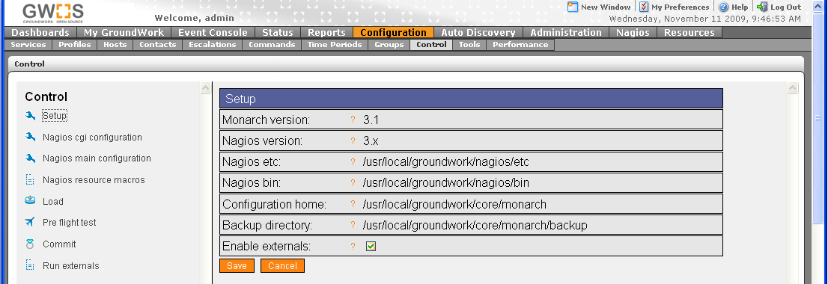

Configure Monarch Group for Windows Child targets
Monarch groups are used to control creation of monarch external definitions used by GDMA agents.

In Configuration→Groups→
- Expand Groups
- Select group windows-gdma
- Select detail page of windows-gdma
- Fill in Description[Optional]
“Monarch group for configuration of gdma targets”
- Fill in Build directory
“/usr/local/groundwork/apache2/htdocs/wchild1”
- Leave all other fields blank
- Select Save
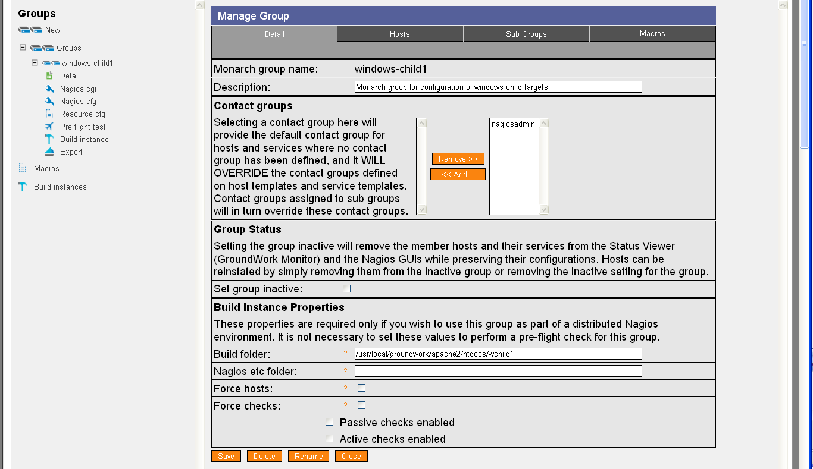

Upload and Import Windows Child Profiles
The Windows Child profile provides a template for the Windows Child host.

In Configuration→Profiles
- Select Profile importer
- Scroll to bottom of screen
- Select Browse and enter location of “windows_child.xml”
- Select upload
- Select Browse and enter location of “service-profile-windows_child.xml”
- Select upload
- Select Browse and enter location of “perfconfig-windows-child.xml”
- Select upload

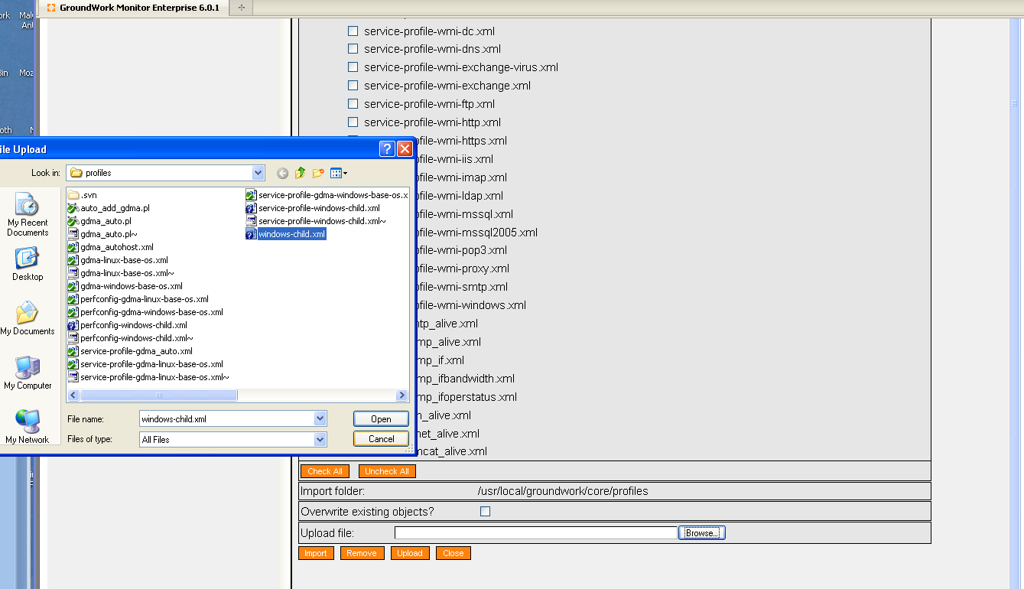

- Toggle Checkbox for windows_child.xml
- Select Import

Create Windows Child Host
This host serves as a collection point for notifications and alerts from the windows child system.

In Configuration→Hosts
- Select Host Wizard
- Fill in Host Name “child-hostname”
- Fill in alias “windows child server”
- Fill in address “xx.xx.xx.xx”
- Select windows_child Host profile

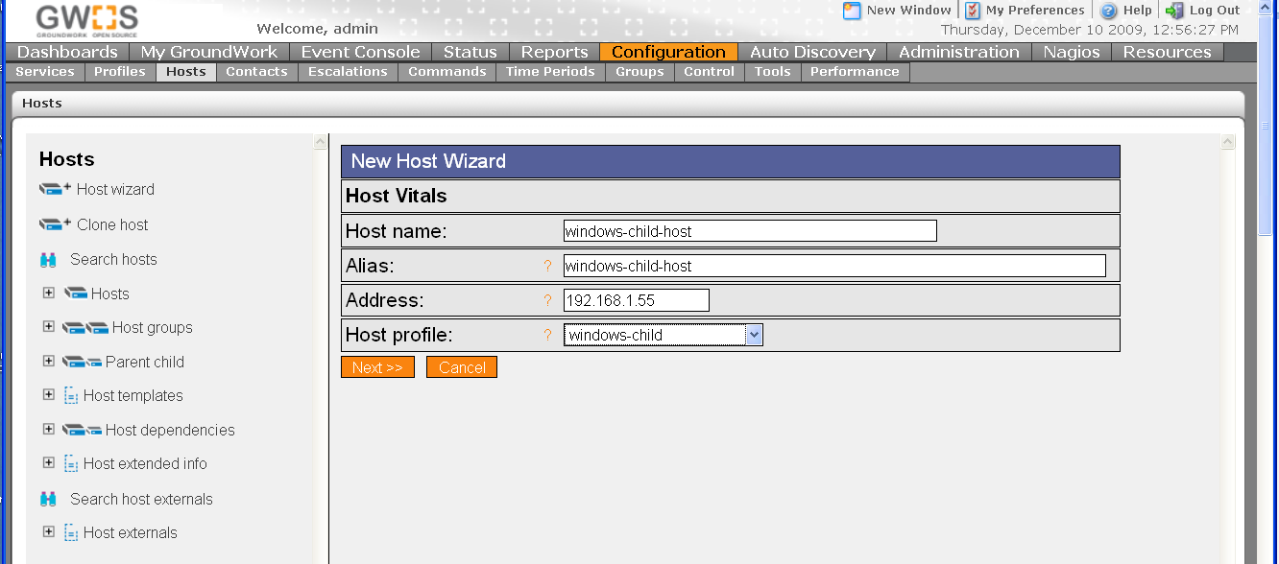

- Select Next,Next,Next,Next,Continue
- Commit Changes to activate

Review and Modify windows-child host externals properties
In Configuration→Hosts→Host Externals
- Select Modify
- Select windows-child

Modify Target_Server parameter
This parameter controls where the windows child will download its host configurations from and where it will send check results. The parameter must be in the form of a url. This parameter is normally set to the hostname or ip address of the Master system. For details on this and other configuration parameters see GDMA Agent Configuration Reference.

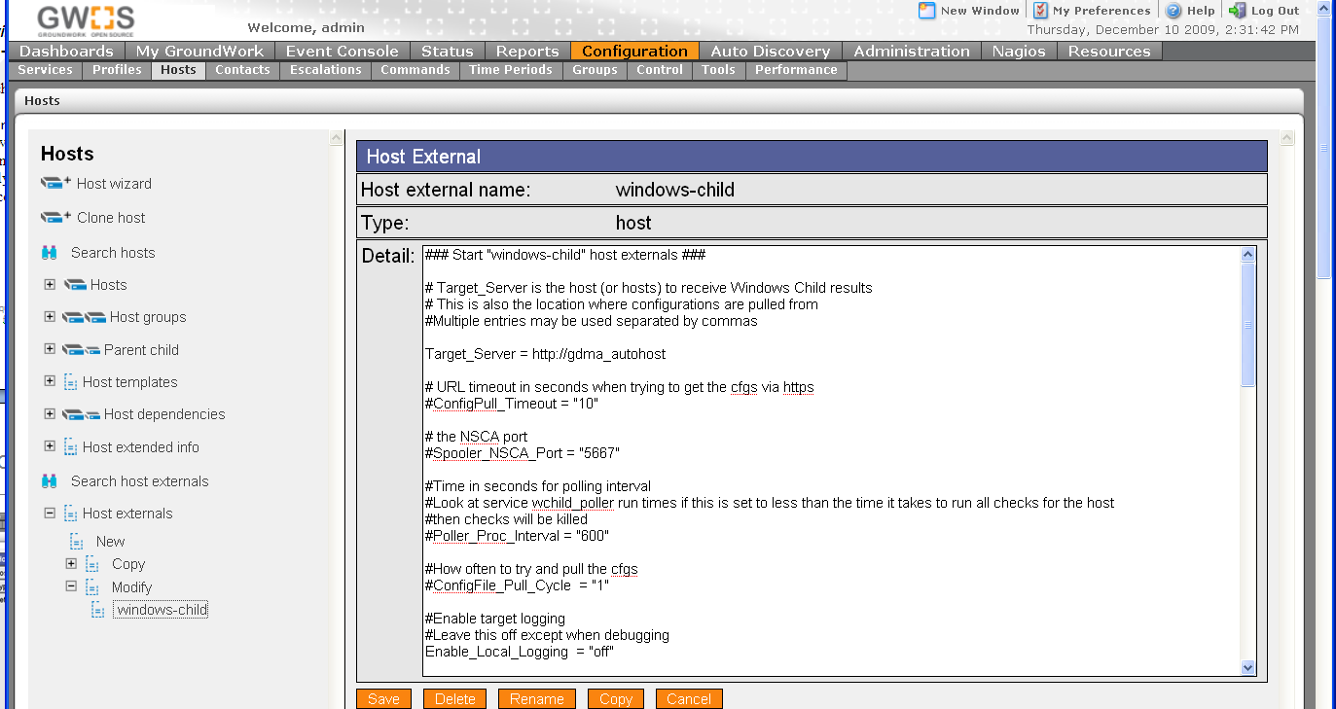

Add windows child host to Monarch Group
In Configuration→Groups
- Expand Groups
- Expand windows-child
- Select Detail
- Select Hosts Tab
- Toggle Checkbox for host E.G. windows-child-host
- Select Add Hosts

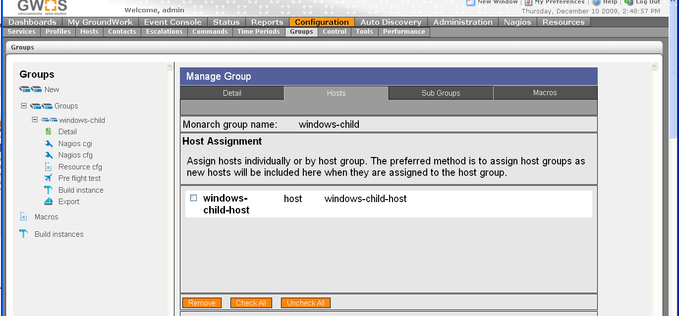

Commit changes and Build Externals
To commit changes to groundwork and create windows child configuration files

In Configuration→Control
- Select Commit, Commit
- Select Run externals

The configuration file will be created in “/usr/local/groundwork/apache2/htdocs/wchild1” as defined in the windows-gdma monarch group. The filename will be gwmon_$hostname.cfg in this example gwmon_windows-child-host.cfg

#ls -al /usr/local/groundwork/apache2/htdocs/wchild1/gwmon_windows-child-host.cfg
-rw-r--r-- 1 nagios nagios /usr/local/groundwork/apache2/htdocs/wchild1/windows-child-host.cfg

Upload and Import Windows Child Target Profiles
The Windows Child Target profile provides configuration parameters for the creation of Windows targets.

In Configuration→Profiles
- Select Profile importer
- Scroll to bottom of screen
- Select Browse and enter location of “windows-child-target.xml”
- Select upload
- Select Browse and enter location of “service-profile-windows-child-target.xml”
- Select upload
- Select Browse and enter location of “perfconfig-windows-child-target.xml”
- Select upload
- Toggle Checkbox for gdma-windows-base-os.xml
- Select Import

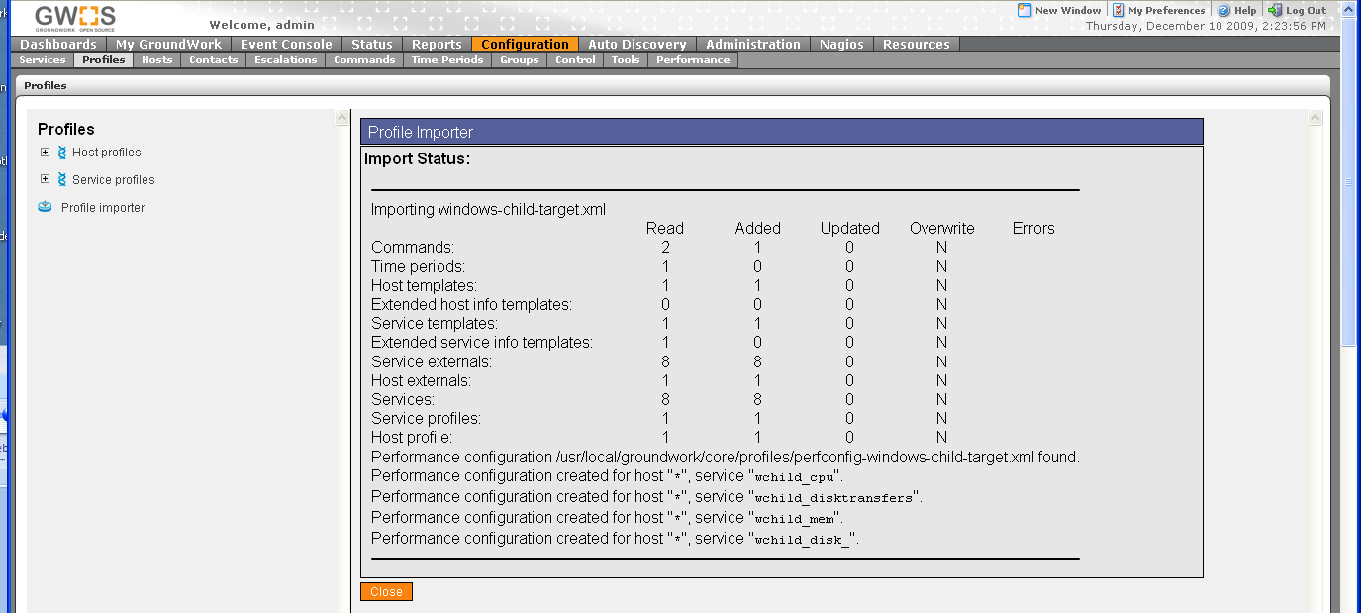

Create/Configure Windows Target

In Configuration→Hosts
- Select Host Wizard
- Fill in Host Name E.G “2000pro”
- Fill in alias E.G.“2000pro”
- Fill in address E.G.“196.168.11.72”
- Select windows-child-target Host profile

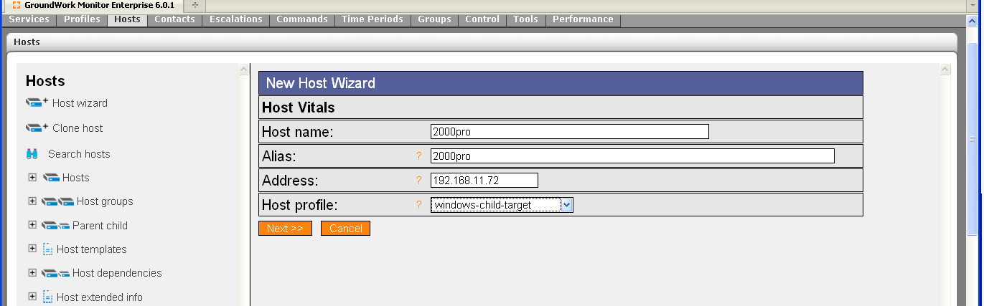

- Select Next,Next,Next,Next,Continue

Add new host to Monarch Group
In Configuration→Groups
- Expand Groups
- Expand windows-child
- Select Detail
- Select Hosts Tab
- Toggle Checkbox for host E.G. 2000pro
- Select Add Hosts

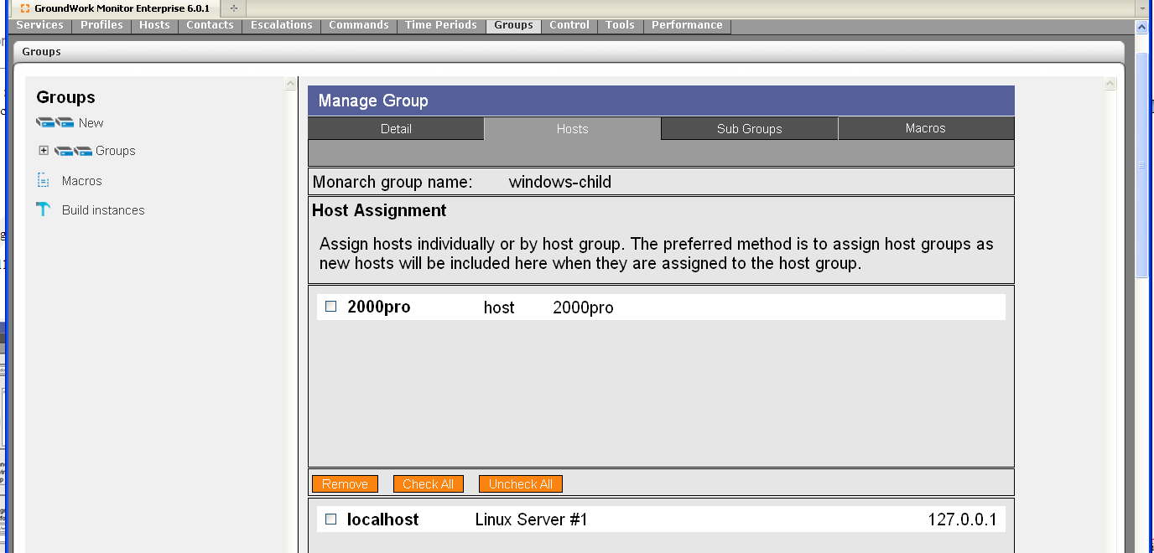

Host will appear in the upper field as an assigned host.

Commit changes and Build Externals
To commit changes to groundwork and create windows child configuration files

In Configuration→Control
- Select Commit, Commit
- Select Run externals

The configuration file will be created in “/usr/local/groundwork/apache2/htdocs/wchild1” as defined in the windows-gdma monarch group. The filename will be gwmon_$hostname.cfg in this example gwmon_2000pro.cfg

#ls -al /usr/local/groundwork/apache2/htdocs/wchild1/gwmon_2000pro.cfg
-rw-r--r-- 1 nagios nagios /usr/local/groundwork/apache2/htdocs/wchild1/gwmon_2000pro.cfg
#

Install Windows Child Software
Create when installer is ready,

Additional Information
GDMA Autoconfiguration and Messaging
GDMA Linux Target Configuration Howto
GDMA Solaris Target Configuration Howto
GDMA Windows Target Configuration Howto
GDMA Agent Configuration Reference

Windows Child operation requires a unified time base for master system and the windows child. This is normally accomplished using an external clock source such as NTP (Network Time Protocol) for all systems.
See Bookshelf Using Applications→Configuration→Configuration Scenarios→Configuring Externals
This directory is controlled by the GDMAConfigDir Configuration parameter. Do not modify this path without consulting GDMA agent documentation.
You may optionally place the host in a hostgroup and configure additional host, service and notification options.

